**BSIC SQL**

--Department Table:

CREATE TABLE poojan_Department

(

id INT NOT NULL PRIMARY KEY,

Department_Name VARCHAR(20) NOT NULL,

Department_Description VARCHAR(200) NOT NULL,

)

--Insert data into Department Table

INSERT INTO poojan_Department VALUES ('01','.Net Developer','The .NET Framework (pronounced as "dot net") is a proprietary software framework developed by Microsoft that runs primarily on Microsoft Windows.');

INSERT INTO poojan_Department VALUES ('02','Java Developer','Java is a popular programming language. Java is used to develop mobile apps, web apps, desktop apps, games and much more.');

INSERT INTO poojan_Department VALUES ('03','Angular Developer','Angular is a platform for building mobile and desktop web applications.');

INSERT INTO poojan_Department VALUES ('04','React Developer','React is a free and open-source front-end JavaScript library for building user interfaces based on UI components. ');

INSERT INTO poojan_Department VALUES ('05','Node Developer','Node.js is an open-source, cross-platform, back-end JavaScript runtime environment that runs on the V8 engine ');

--Show Department Table data

SELECT * FROM poojan_Department;

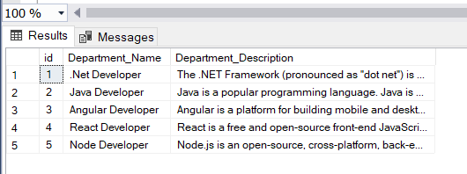

--Employee Table

CREATE TABLE poojan_employee

(

EmpId INT NOT NULL PRIMARY KEY,

FirstName VARCHAR(15) ,

LastName VARCHAR(15),

City VARCHAR(20),

MobileNumber INT NOT NULL,

Gender VARCHAR(7) NOT NULL,

--Foreign Key Department Table

Department INT NOT NULL,

FOREIGN KEY (Department) REFERENCES poojan_Department(id),

Email VARCHAR(15) NOT NULL,

Adress VARCHAR(100) ,

Age INT,

UserName VARCHAR(15) NOT NULL,

Emp_Password VARCHAR(10) NOT NULL UNIQUE,

Emp_Confirm_Password VARCHAR(10) NOT NULL UNIQUE

);

--Insert Data into Employee Table

INSERT INTO poojan_employee values('101','Poojan','Patel','Vadodara','987654321','Male','04','poojan@gmail','C-304,Rudhraksh Flats,Vadoadara','22','poojan@3037','poojan123','poojan123');

INSERT INTO poojan_employee values('102','Smit','Patel','Mehasana','987651234','Male','03','smit@gmail','A-Shiv Society,Mehsana','24','smit@3037','smit123','smit123');

INSERT INTO poojan_employee values('103','Kevin','Vasoya','Rajkot','974651234','Male','02','kevin@gmail','S-Om Society,Mehsana','19','kevin@3037','kevin123','kevin123');

INSERT INTO poojan_employee values('104','Neha','Chawda','Vadodara','987441234','Female','05','neha@gmail','A-Neha Society,Mehsana','32','neha@3037','neha123','neha123');\

INSERT INTO poojan_employee values('105','Meera','Shah','Mumbai','987651233','Female','04','meera@gmail','A-meera Society,Mumbai','24','meera@3037','meera123','meera123');

--Shoe Employee Table Data

SELECT * FROM poojan_employee;

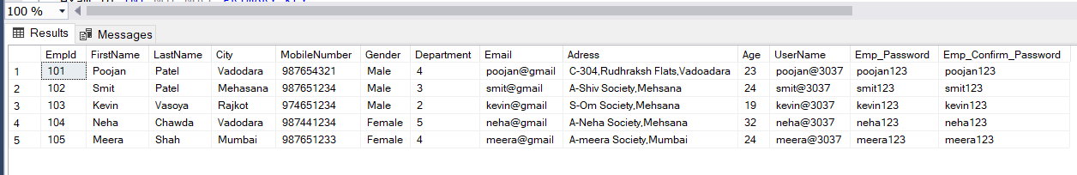

--Create Exam Table

CREATE TABLE poojan_exam

(

exam_id INT NOT NULL PRIMARY KEY,

--Foreign key of Employee Table

Exam_empId INT NOT NULL,

FOREIGN KEY (Exam_empId) REFERENCES poojan_employee(EmpId),

title VARCHAR(15),

exam_description VARCHAR(100),

marks INT,

exam_date DATE

)

--Insert data into exam table

INSERT INTO poojan_exam VALUES ('1001','101','junior dev.','Exam for junior developer','70','2021-10-11');

INSERT INTO poojan_exam VALUES ('1002','102','tester dev','Exam for tester developer','58','2021-09-14');

INSERT INTO poojan_exam VALUES ('1003','101','frontend dev.','Exam for frontend developer','85','2022-06-23');

INSERT INTO poojan_exam VALUES ('1004','104','senior dev.','Exam for senior developer','67','2022-02-11');

INSERT INTO poojan_exam VALUES ('1005','103','backend dev.','Exam for backend developer','84','2022-07-24');

--show exam table data

SELECT * FROM poojan_exam;

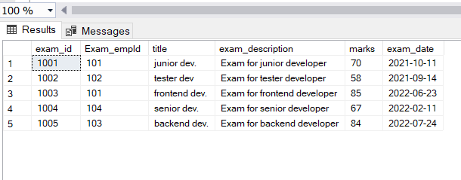

--update age 23 of employee whoes id is 101

UPDATE poojan_employee SET Age='23' WHERE EmpId='101';

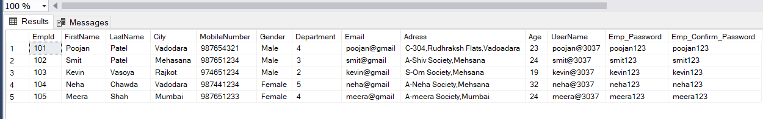

--delete data of emoloyee whose id is 105

DELETE FROM poojan_employee WHERE EmpId='105';

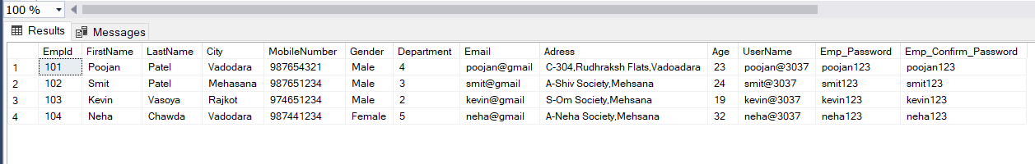

--show total number of employee on the basis of city

SELECT COUNT(FirstName),City FROM poojan_employee GROUP BY(City);

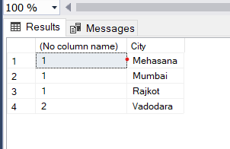

--alter

ALTER TABLE poojan_employee ALTER COLUMN City VARCHAR(15);

--show data in asccending order

SELECT * FROM poojan_exam ORDER BY Marks ASC;

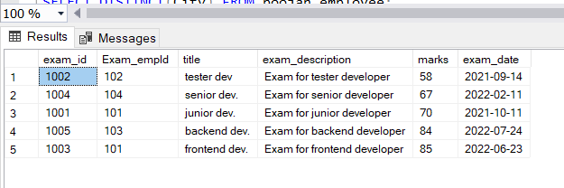

--distinct

SELECT DISTINCT(City) FROM poojan_employee;

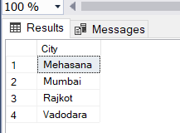

--lastname starts with Pa

SELECT FirstName from poojan_employee WHERE LastName LIKE 'Pa%';

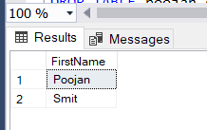

--Firstname contain sub-string oo

SELECT FirstName from poojan_employee WHERE FirstName LIKE '%oo%';

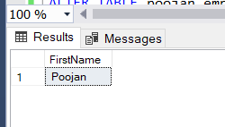

--DROP table

DROP TABLE poojan_exam;

--Add new coloumn

ALTER TABLE poojan_employee ADD Birthday DATE;